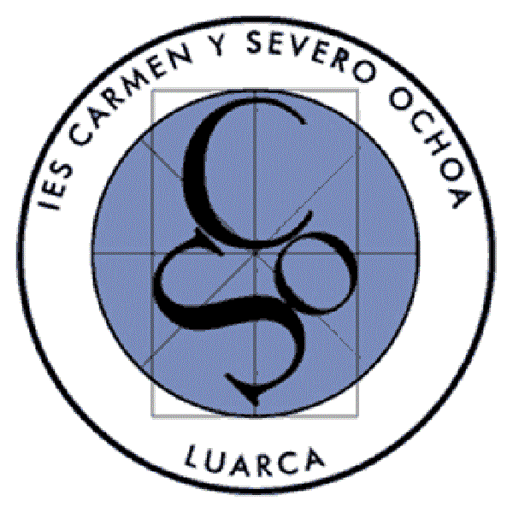
COOPERATIVE LEARNING
A few years ago, some teachers at our school were told about a new methodology that was working very well at those schools where it was being implemented. This new methodology was called “Cooperative Learning”, those teachers were captivated by it and decided to learn more about it and implement it at our school.
Now, some of those teachers are experts on this matter and have even given training sessions at other schools.
I think that the main reason why these teachers, and others that followed, decided to use this methodology in their lessons was that it is a very inclusive methodology that allows each and every student to do their best and contribute to the fulfilment of the group success and their own.
Here you’ll find the basic information about this methodology and also a short description of some of the techniques that can be used to carry out different activities.
Nowadays, there is a lot of available bibliography and information on this topic in case someone wants to go deeper and learn more about it.
DEFINITION:
Cooperative learning is a methodology that is based on the organisation of the classroom in small mixed and heterogeneous groups. The students work together in a coordinate way in order to solve their tasks and deepen in their own learning process. One of the goals of this methodology is to bind together the objectives of the participants so that each of them can only achieve their goals if the others achieve theirs too. The students in each group have to interact according to a carefully designed plan which induces the reciprocal influence of the members of the students’ team.
HOW TO START IMPLEMENTING COOPERATIVE LEARNING:
1. Make heterogeneous groups: the students can work with their classmates in groups that view being different as an opportunity of learning.
2. Organise the classroom: space facilitates teamwork and helps control the process.
3. Assign roles and settle working rules.
4. Promote positive interdependence: the students depend on one another in order to achieve their goals.
5. Ensure participation: There are mechanisms that help check how much and how well each student works and their contribution to the common task.
6. Guarantee success: the skills required for the task go according to the students.
7. Encourage the interindividual processing of information: the students talk about what they learn.
8. Enhance reflection on teamwork: the students have the opportunity to think about the way they work.
STUDENTS ROLES WITHIN THE TEAM AND THEIR FUNCTIONS
These are some examples of the most common roles; they can also be found with different names and with different functions. Normally, teachers use the assignation of the roles to, somehow, challenge the students. For example, the quietest student is named speaker of the group.
SUPERVISOR:
- The supervisor makes sure that all the members of the team write down/have all the instructions about the task that has to be carried out.
- They check that all the members of team the have done their part of the task.
- They write down the instructions and answers of collective tasks.
MATERIALS MANAGER:
- The materials’ manager supervises that the working area is clean and in order.
- They remind the others about the material they must have every day.
- They are in charge of the materials when there is a collective task.
SPEAKER:
- The speaker supervises the level of noise when they are carrying out a group activity.
- They are in charge of communicating with the teachers in order to ask questions, clear any doubts and check collective tasks.
COORDINATOR:
- The coordinator organizes the task and checks the timeline.
- They assign the turn to speak when the team is working together.
- They check that everyone does their duty and inform the teacher about it.
COOPERATIVE LEARNING TECHNIQUES
Currently, there are a lot of techniques that can be used in cooperative learning. These are just a few examples:
- The Jig- Saw: Students are grouped into five or six and each group is assigned a specific task. Then, they come back to the group and teach one another what they have learned.
- Think-Pair-Share: Each member of the group “thinks” of a question from what they have just learned. Then, they “pair up” with another member and they discuss their answers to the question. Finally, they “share” what they have learned with the rest of the group or class.
- Pens-in-the-Middle: The students have to solve some problem, answer to some questions, etc. They place their pens in the middle and they discuss about the solution to the problem, the answer to the questions, etc. All the students have to talk and contribute. Once they have come to an agreement about the correct solution or answers, they take their pens and write the answers.
- Writearound: A sentence or topic is given to the students and they have some time to think about it. The first student has some time, about one or two minutes, to write about the topic, then, another student does the same until all the members of the group have written something on the paper. It can be done as many times as necessary until the task is completed. This technique can be used for creative writing purposes, for drawing stories, etc.
- Group Investigation: each member of the group is in charge of researching or carrying out one part of a whole topic or task. Once they have done their part, they put all the parts together and deliver the final outcome.
- 1-2-4: each student works individually on the answer to one or more questions and they write them down. Then, they share their answers with another member of the group, come to an agreement about them and write them down. Finally, the four members of the group share the answers each pair has and come to an agreement about them. They write them down. This technique is very simple and can be used to carry out many different activities, such as reading comprehension, problem solving, etc.
As said before, these are just a few examples of cooperative learning techniques that can be easily implemented in the classroom.
As far as the evaluation is concerned, all the students have to be assessed both for their individual work and for their group work.
To finish, I’d like to highlight the three most relevant benefits that cooperative learning
provides educational work:
1. It improves all the students’ learning.
2. It contributes to avoid school dropout.
3. It enhances harmony among the students in the classroom and at the school.
https://creativecommons.org/licenses/by-nc/4.0/

