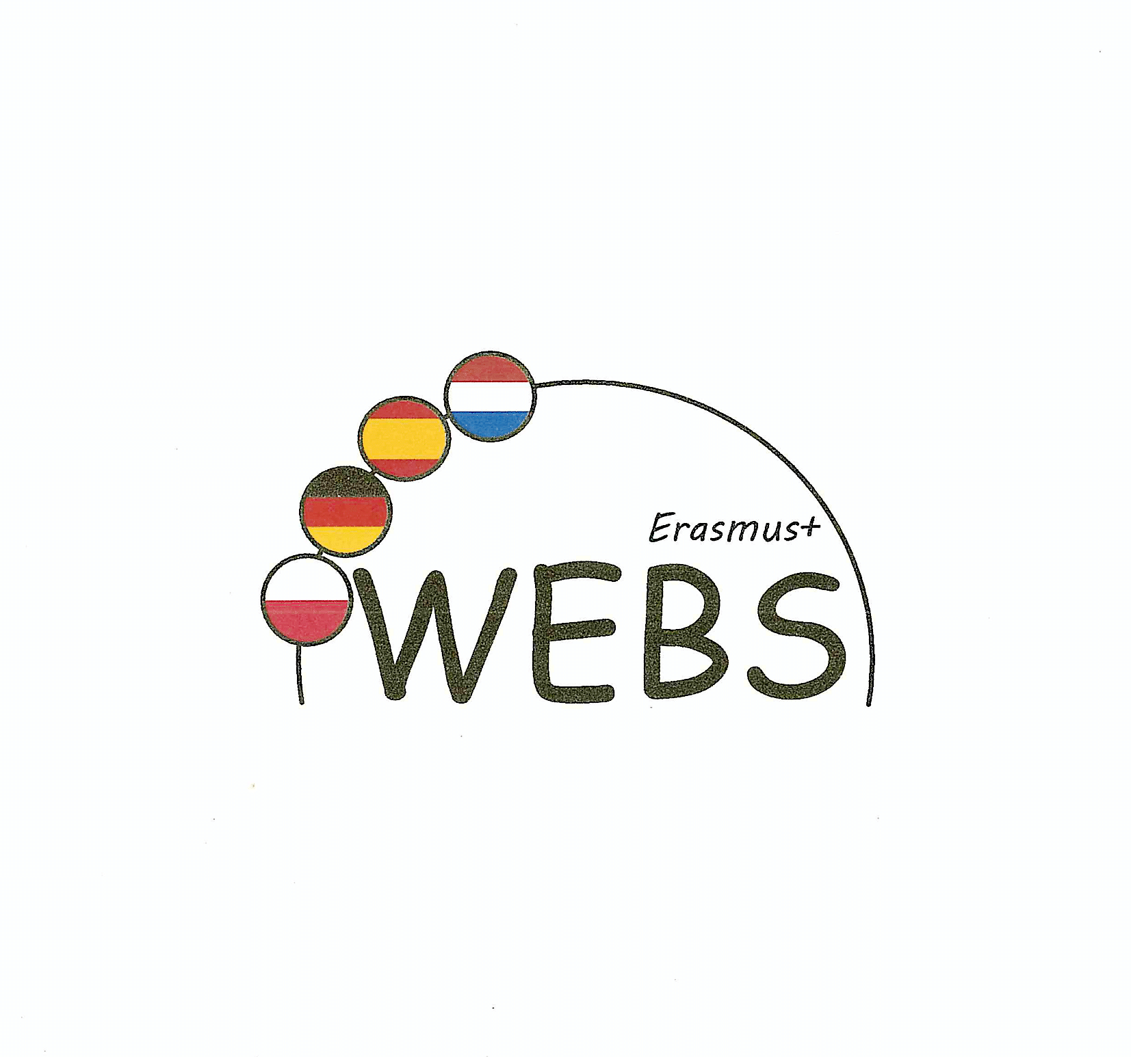

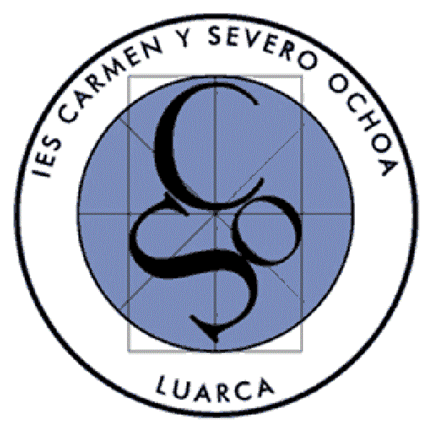
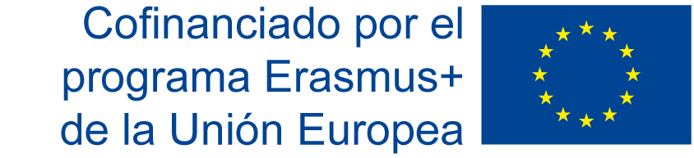

Meeting in Katowice from 18th to 22nd November 2019
Report by the Spanish Coordinator.

As part of the Eramus + project we’re part of, eleven students and three teachers (one French teacher, one English teacher and one history teacher) of our school “IES Carmen y Severo Ochoa” of Luarca, Spain, had the opportunity of participating in the “Learning/Teaching/Training Activities” that took place in Katowice, from 18th to 22nd November 2019.

The students were hosted by some Polish students; it was the first time they met, although they had had some contact via social media prior to the meeting. They were warmly welcome and, from the very beginning, they got on very well.
As for the teachers, we had the opportunity to see again some of the teachers of the three partner schools that we had met during the short exchange organised by our school in February 2019 and in Berlin in September 2019, which helped reinforce the bonds between us and provided a good atmosphere. The teachers form Kopernik High School really did their best to provide us with everything we needed. We felt like home.

We live in a very small city on the north coast of Spain, so, to start with, the journey itself was a experience of great value for the students, considering, for example, that, for three of them, it was the first time they travelled by plane. Having the opportunity of visiting a big city like Katowice meant also a lot to our students. This exchange provided our students with not only the opportunity of working on the project together with their mates of the three partner schools, but also the chance of visiting a city with a very different background.

The students attended a few lessons and on their comments about them they liked things like the fact of being able to eat in the classrooms and the kindness of teachers and students. They also liked very much the lesson on the “Bystander Effect” with Ms Bożena Knichowiecka.
They found that the resources and the methodology are quite similar to ours.

With respect to the teachers’ observation about the school in general, we can only show but sympathy with respect to the current situation the school is going through: the numerous lessons, the lack of classrooms, the crowded lessons, the fact of having no breaks for meals, etc. Despite all this, we could see that everybody is doing their best and it doesn’t seem to be affecting the students’ learning process, but it can’t be said the same for sure about the teachers’ state. The teachers didn’t have the chance to attend to many lessons but we still can highlight a few things that we noticed and liked very much: the high level of participation and good behaviour of the students during the lessons and the high level of linguistic immersion in French during the lessons.
With respect to the resources and methodology used by the teachers in the classroom, they’re quite similar to ours.

As for the bilingualism at the school, first of all it has to be said that the old and the new system that is currently being implemented are overlapped. It means that there are differences between the studies following the old system and the studies following the new system. The old system seems quite similar to ours. As far as the new system is concerned, there was something that really shocked us. After compulsory secondary education, those students who want to get into the bilingual high secondary education have a sort of transition year and, during that year, they have no less than eighteen lessons of French a week, and just a few lessons of other main subjects. The teachers of the bilingual section don’t have to be native speakers, the same as at our school, although one of them is. They don’t have a language assistant.

This meeting meant a lot to all the participants of our school. The bonds with our mates and co-workers became stronger, we had the chance to meet new students and teachers of the partner schools, we learned a lot about how the school works and we had the chance to explore and get to know more about Poland in general and Katowice in particular.

