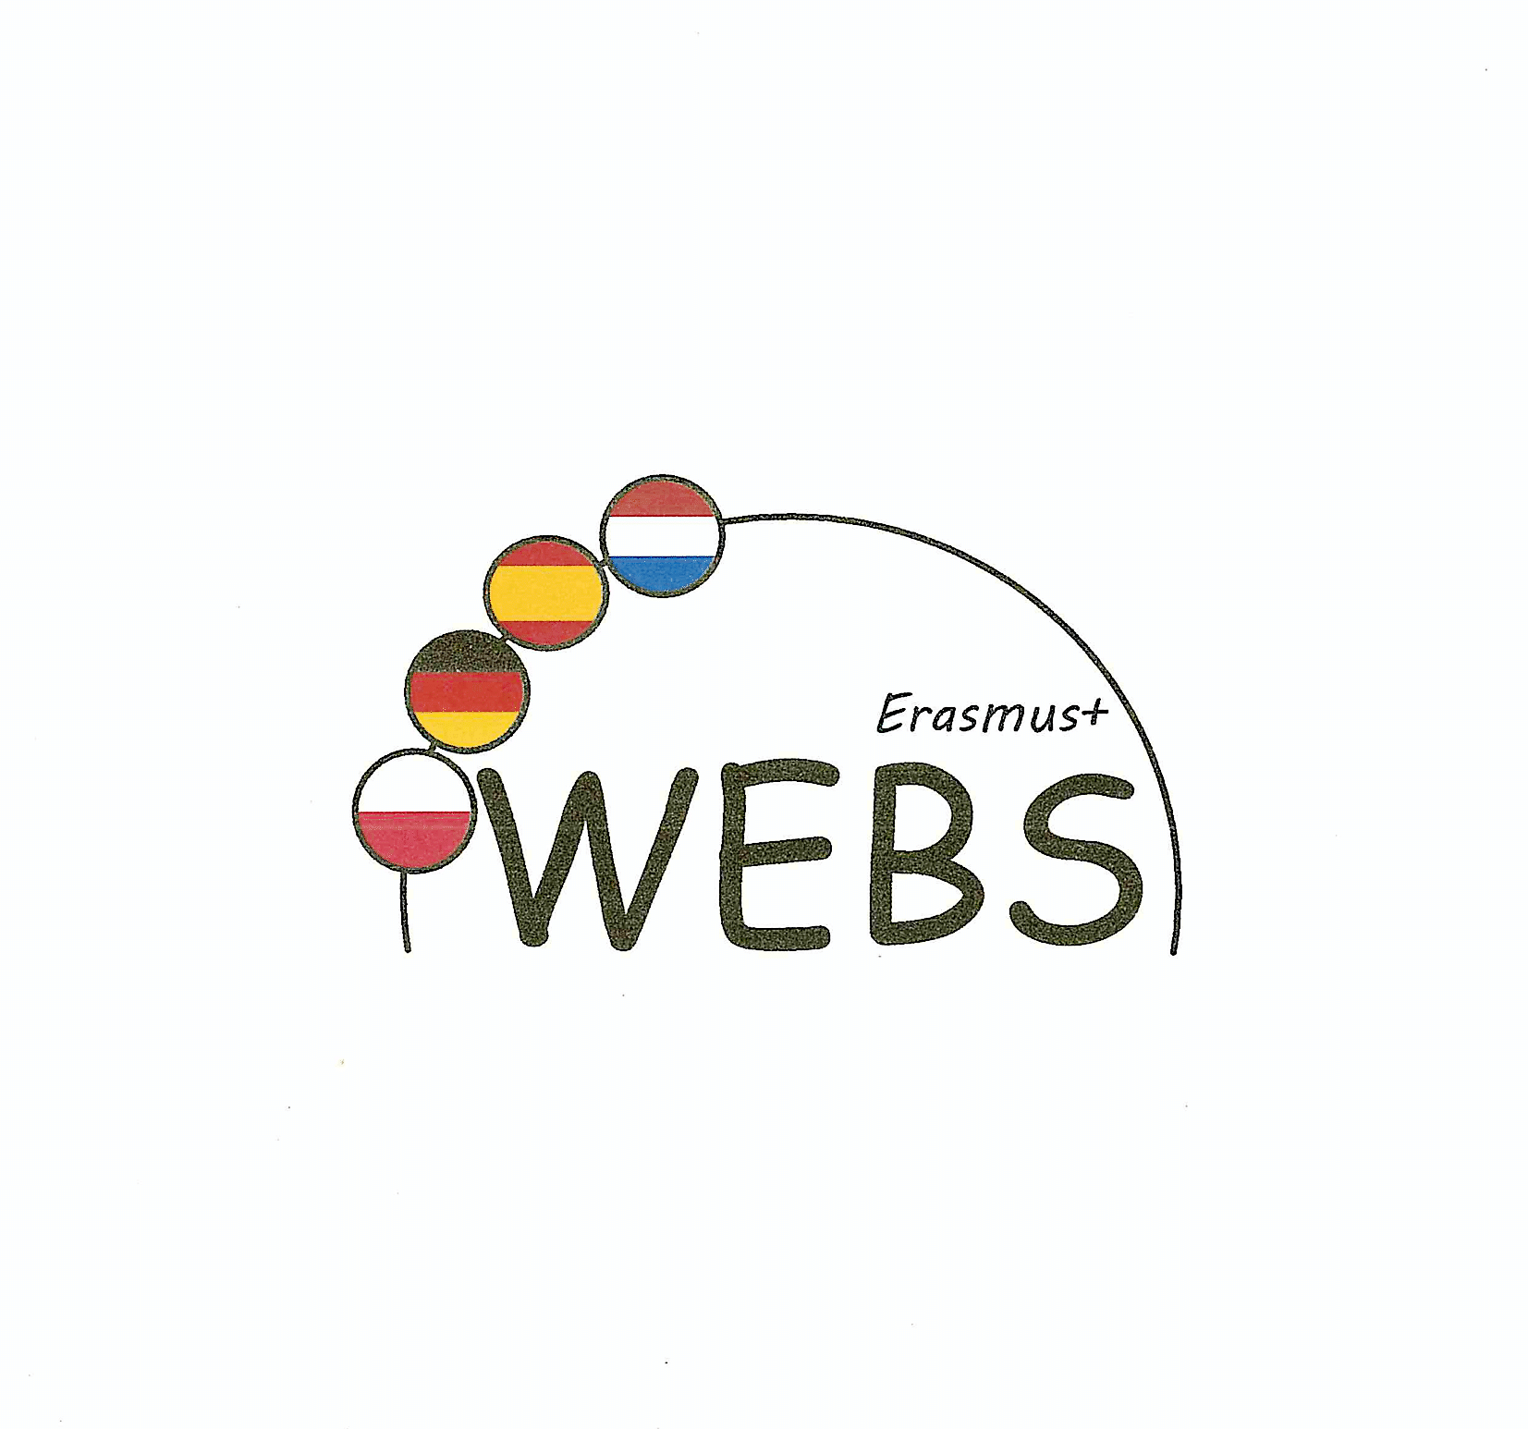

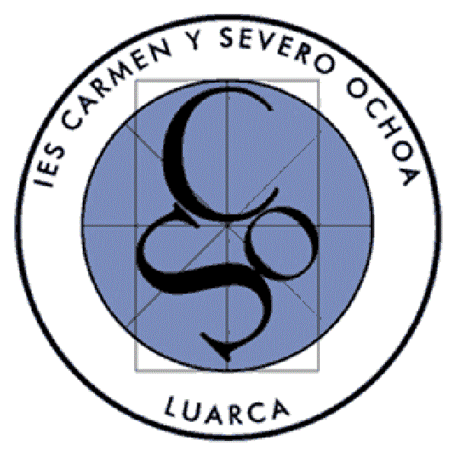
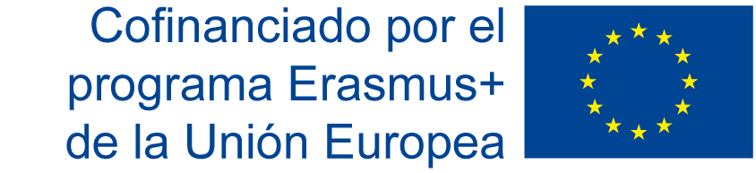

Meeting in Berlin from 16th to 20th September 2019
Report by the Spanish Coordinator.

As part of the Eramus + project we’re part of, nine students and three teachers of our school “IES Carmen y Severo Ochoa” of Luarca, Spain, had the opportunity of participating in some “Learning/Teaching/Training Activities” that took place in Berlin, from 16th to 20th September 2019.
The students were hosted by some German students, the same students they had hosted when the first meeting of our partnership took place in our hometown. It meant that they all had met previously and were happy to see each other again. There was no need of “breaking the ice” for them.
Something similar happened with the teachers, we had the opportunity to see some of the teachers of the three partner school that we had met during the short exchange organised by our school in February 2019.
We live in a very small city on the north coast of Spain, so, to start with, the fact of travelling to a big city like Berlin was very exciting, especially for the students. This exchange provided our students with not only the opportunity of working on the project together with their mates of the three partner schools, but also the chance of visiting a city with great historical significance and of facing the challenges of living in a such a place. From simple things as taking the underground to being witnesses of a multicultural society, its advantages and disadvantages, everything so different form their hometown.
As for the school and its organisation, the students relay on their observation sheets a few aspects that called their attention, such as the different schedules and timetables and longer classes. They also state that the factual bilingualism of the lessons provide the students with the real possibility of learning both languages very well. They attended a few lessons and on their comments about them they liked things like the booth for dangerous experiments in the lab, the fact that they could listen to music while doing their exercises. They also found that the lesson at the Oberschule in Berlin are not so different compared to the lessons at our school.
With respect to the teachers observation about the school in general and some lessons in particular, it has to be said that we had the opportunity to learn a lot about the distribution of the students, the levels, and many other interesting facts. The teachers didn’t have the chance to attend to many lessons but we still can highlight a few things that we noticed and liked very much: the high level of participation of the students during the lessons, the positive feedback that they all got and well managed behaviour of the students.
With respect to the resources used by the teachers in the classroom, they’re quite similar to ours.
The concept of bilingualism is totally different at the German school with respect to our school. At the German school, most of the students in the bilingual section have Spanish or Latin-American roots, so they already speak Spanish when they join this program. Most of the teachers that teach the lessons with Spanish as the language of instruction are Spanish native speakers too. At our school, there are no French or English native speakers among the students or the teachers, except for the language assistants, so both our students and teachers have to make a greater effort.
This meeting meant a lot to all the participants of our school. The bonds with our mates and co-workers became stronger, we had the chance to meet new students and teachers of the partner schools, we learned a lot about how the school works and we had the chance to explore and get to know more the wonderful city of Berlin.

